1.65: Let 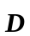 be the fourth force.

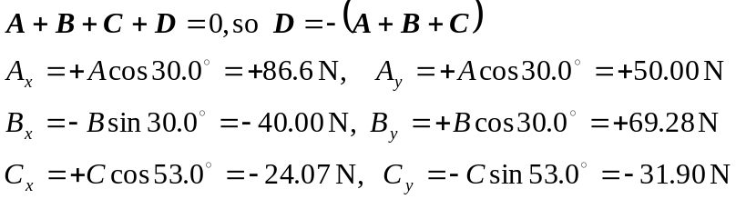
Then 